The model acheived 85% accuracy on the validation set.

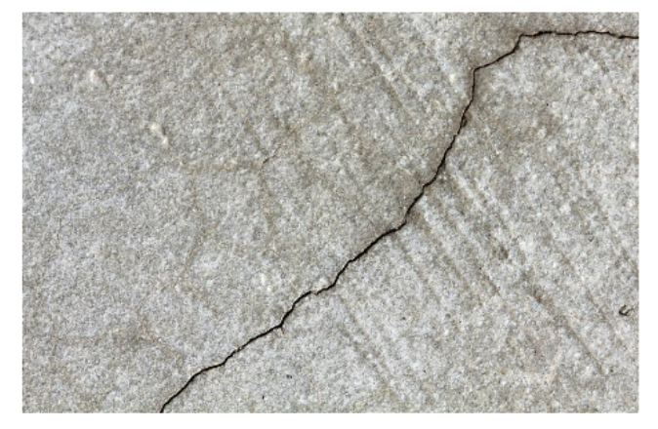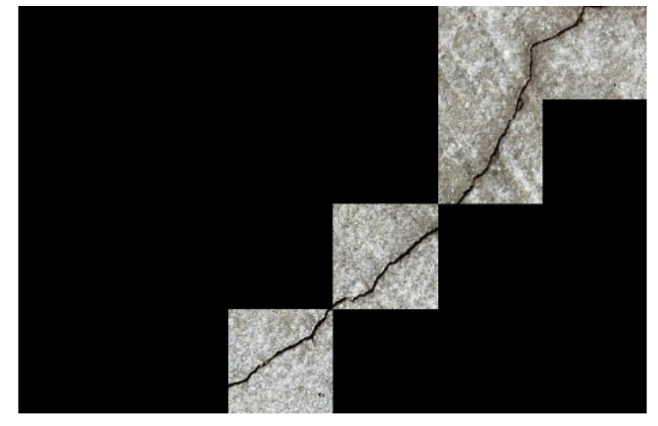

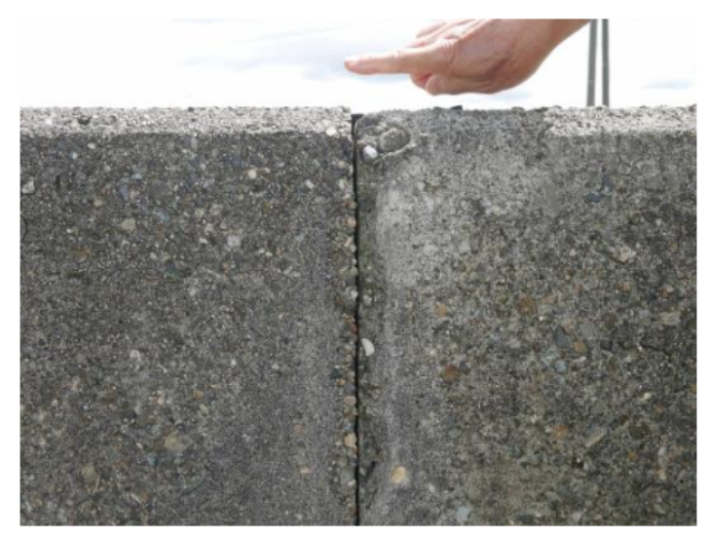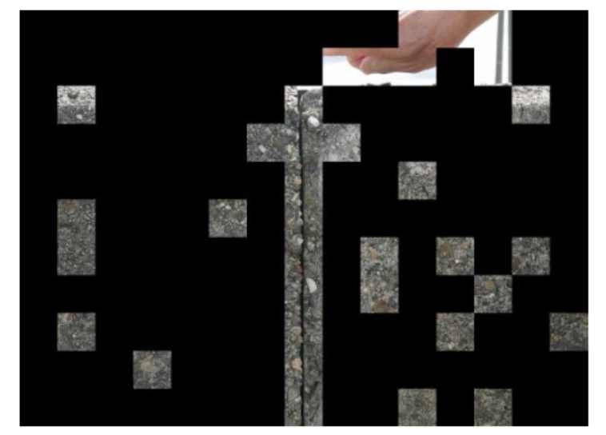

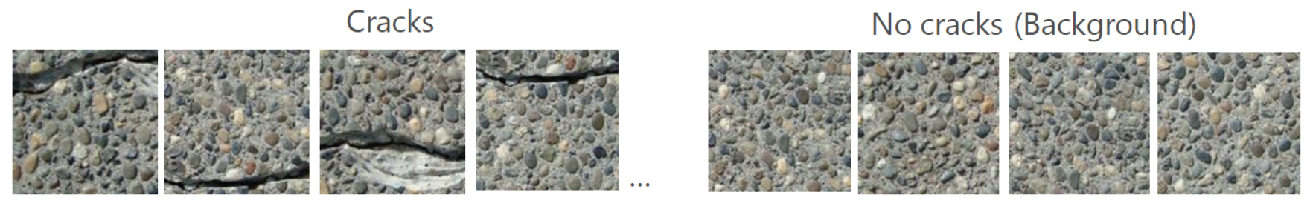

The dataset I used :

<https://drive.google.com/file/d/1kC60RGO3rcScVk7HY-s7tTMJeMbADfh1/view>

Selected Code:

"""

Code to train the model

"""

import tensorflow as tf

import numpy as np

import time

from datetime import timedelta

from dataset import load_cached

#from matplotlib.image import imread

import cv2,sys,argparse

#Initialzing the conv and max_pool layers

#####################################################

def new_conv_layer(input,              # The previous layer.

                   num_input_channels, # Num. channels in prev. layer.

                   filter_size,        # Width and height of each filter.

                   num_filters):        # Number of filters.

    # Shape of the filter-weights for the convolution.

    shape = [filter_size, filter_size, num_input_channels, num_filters]

    # Create new weights aka. filters with the given shape.

    weights = tf.Variable(tf.truncated_normal(shape, stddev=0.05))

    # Create new biases, one for each filter.

    biases = tf.Variable(tf.constant(0.05, shape=[num_filters]))

    layer = tf.nn.conv2d(input=input,

                         filter=weights,

                         strides=[1, 2, 2, 1],

                         padding='VALID')

    # A bias-value is added to each filter-channel.

    layer += biases

    return layer

####################################################

def max_pool(layer,ksize,strides):

    layer = tf.nn.max_pool(value=layer,

                           ksize=ksize,

                           strides = strides,

                           padding = 'VALID')

    return layer

####################################################

def new_fc_layer(input,           # The previous layer.

                 num_inputs,      # Num. inputs from prev. layer.

                 num_outputs,     # Num. outputs

                 use_relu=True):  # Use Rectified Linear Unit (ReLU)?

    # Create new weights and biases.

    weights =tf.Variable(tf.truncated_normal([num_inputs, num_outputs], stddev=0.05))

    biases = tf.Variable(tf.constant(0.05, shape=[num_outputs]))

    #Include Drop-out as well to avoid overfitting

    #x_drop = tf.nn.dropout(input, keep_prob=keep_prob_input)

    # Calculate the layer as the matrix multiplication of

    # the input and weights, and then add the bias-values.

    layer = tf.matmul(input, weights) + biases

    # Use ReLU?

    if use_relu:

        layer = tf.nn.relu(layer)

    return layer

####################################################

def flatten_layer(layer):

    # Get the shape of the input layer.

    layer_shape = layer.get_shape()

    # The shape of the input layer is assumed to be:

    # layer_shape == [num_images, img_height, img_width, num_channels]

    # The number of features is: img_height * img_width * num_channels

    num_features = layer_shape[1:4].num_elements()

    layer_flat = tf.reshape(layer, [-1, num_features])

    # The shape of the flattened layer is now:

    # [num_images, img_height * img_width * num_channels]

    return layer_flat, num_features

####################################################

class Model:

    def __init__(self,in_dir,save_folder=None):

        dataset = load_cached(cache_path='my_dataset_cache.pkl', in_dir=in_dir)

        self.num_classes = dataset.num_classes

        image_paths_train, cls_train, self.labels_train = dataset.get_training_set()

        image_paths_test, self.cls_test, self.labels_test = dataset.get_test_set()

        ##############################IMAGE PARAMETERS#####################################

        self.img_size = 128

        self.num_channels = 3

        self.train_batch_size = 64

        self.test_batch_size = 64

        ###################################################################################

        self.x = tf.placeholder(tf.float32, shape=[None, self.img_size,self.img_size,self.num_channels], name='x')

        self.x_image = tf.reshape(self.x, [-1, self.img_size, self.img_size, self.num_channels])

        self.y_true = tf.placeholder(tf.float32, shape=[None, self.num_classes], name='y_true')

        self.y_true_cls = tf.argmax(self.y_true, axis=1) #The True class Value

        self.keep_prob = tf.placeholder(tf.float32)

        self.keep_prob_2 = tf.placeholder(tf.float32)

        self.y_pred_cls = None

        self.train_images= self.load_images(image_paths_train)

        self.test_images= self.load_images(image_paths_test)

        self.save_folder=save_folder

        self.optimizer,self.accuracy = self.define_model()

    def load_images(self,image_paths):

        # Load the images from disk.

        images = [cv2.imread(path,1) for path in image_paths]

        # Convert to a numpy array and return it in the form of [num_images,size,size,channel]

        #print(np.asarray(images[0]).shape)

        return np.asarray(images)

    def define_model(self):

        #Convolution Layer 1

        filter_size1 = 10          # Convolution filters are 10 x 10

        num_filters1 = 24         # There are 24 of these filters.

        # Convolutional Layer 2

        filter_size2 = 7          # Convolution filters are 7 x 7

        num_filters2 = 48         # There are 48 of these filters.

        # Convolutional Layer 3

        filter_size3 = 11          # Convolution filters are 11 x 11

        num_filters3 = 96         # There are 96 of these filters.

        # Fully-connected layer

        fc_size = 96

        layer_conv1 = new_conv_layer(input=self.x_image,

                                     num_input_channels=self.num_channels,

                                     filter_size=filter_size1,

                                     num_filters=num_filters1)

        #Max Pool Layer

        ksize1 = [1,4,4,1]

        strides1 = [1,2,2,1]

        layer_max_pool1 = max_pool(layer_conv1,ksize1,strides1)

        #Convolutional Layer 2

        layer_conv2 = new_conv_layer(input=layer_max_pool1,

                                     num_input_channels=num_filters1,

                                     filter_size=filter_size2,

                                     num_filters=num_filters2)

        #Max Pool Layer

        ksize2 = [1,2,2,1]

        strides2 = [1,1,1,1]

        layer_max_pool2 = max_pool(layer_conv2,ksize2,strides2)

        #Convolutional Layer 3

        layer_conv3 = new_conv_layer(input=layer_max_pool2,

                                     num_input_channels=num_filters2,

                                     filter_size=filter_size3,

                                     num_filters=num_filters3)

        #Flatten

        layer_flat, num_features = flatten_layer(layer_conv3)

        #Relu Layer

        layer_relu = tf.nn.relu(layer_flat)

        #Fully-Connected Layer1

        layer_fc1 = new_fc_layer(input=layer_relu,

                                 num_inputs=num_features,

                                 num_outputs=fc_size,

                                 use_relu=True)

        #Fully-Connected Layer2

        layer_fc2 = new_fc_layer(input=layer_fc1,

                                 num_inputs=fc_size,

                                 num_outputs=self.num_classes,

                                 use_relu=False)

        #Predict the class

        y_pred = tf.nn.softmax(layer_fc2)

        self.y_pred_cls = tf.argmax(y_pred, dimension=1,name="predictions")

        #Cost Function

        cross_entropy = tf.nn.softmax_cross_entropy_with_logits(logits=layer_fc2, labels=self.y_true)

        cost = tf.reduce_mean(cross_entropy)

        optimizer = tf.train.AdamOptimizer(learning_rate=1e-4).minimize(cost)

        #Predict

        correct_prediction = tf.equal(self.y_pred_cls, self.y_true_cls)

        accuracy = tf.reduce_mean(tf.cast(correct_prediction, tf.float32))

        return optimizer, accuracy

    def random_batch(self):

        # Number of images in the training-set.

        num_images = len(self.train_images)

        # Create a random index.

        idx = np.random.choice(num_images,

                               size=self.train_batch_size,

                               replace=False)

        # Use the random index to select random x and y-values.

        x_batch = self.train_images[idx]

        y_batch = self.labels_train[idx]

        return x_batch, y_batch

    def print_test_accuracy(self,sess):

        # Number of images in the test-set.

        num_test = len(self.test_images)

        # Allocate an array for the predicted classes which

        # will be calculated in batches and filled into this array.

        cls_pred = np.zeros(shape=num_test, dtype=np.int)

        i = 0

        while i < num_test:

            # The ending index for the next batch is denoted j.

            j = min(i + self.test_batch_size, num_test)

            images = self.test_images[i:j]

            labels = self.labels_test[i:j]

            # Create a feed-dict with these images and labels.

            feed_dict = {self.x: images,

                 self.y_true: labels,

                 self.keep_prob: 1,

                 self.keep_prob: 1}

            cls_pred[i:j] = sess.run(self.y_pred_cls, feed_dict=feed_dict)

            # Set the start-index for the next batch to the

            # end-index of the current batch.

            i = j

        # Create a boolean array whether each image is correctly classified.

        correct = (self.cls_test == cls_pred)

         # Classification accuracy is the number of correctly classified

        # images divided by the total number of images in the test-set.

        acc = float(correct.sum()) / num_test

        # Print the accuracy.

        msg = "Accuracy on Test-Set: {0:.1%} ({1} / {2})"

        print(msg.format(acc, correct.sum(), num_test))

    def optimize(self, num_iterations):

        # Ensure we update the global variable rather than a local copy.

        global total_iterations

        total_iterations = 0

        saver = tf.train.Saver()

        # Start-time used for printing time-usage below.

        start_time = time.time()

        with tf.Session() as sess:

            #global_step_int = tf.train.get_global_step(sess.graph)

            sess.run(tf.global_variables_initializer())

            for i in range(total_iterations,

                           total_iterations + num_iterations):

                # Get a batch of training examples.

                # x_batch now holds a batch of images and

                # y_true_batch are the true labels for those images.

                x_batch, y_true_batch = self.random_batch()

                feed_dict_train = {self.x: x_batch,

                                   self.y_true: y_true_batch}

                                   #self.keep_prob: 0.5,

                                   #self.keep_prob: 0.5}

                sess.run([self.optimizer], feed_dict=feed_dict_train)

                # Print status every 100 iterations.

                if i % 100 == 0:

                    # Calculate the accuracy on the training-set.

                    feed_dict_acc = {self.x: x_batch,

                                     self.y_true: y_true_batch}

                                     #self.keep_prob: 1,

                                     #self.keep_prob: 1}

                    acc = sess.run(self.accuracy, feed_dict=feed_dict_acc)

                    # Message for printing.

                    msg = "Optimization Iteration: {0:>6}, Training Accuracy: {1:>6.1%}"

                    # Print it.

                    print(msg.format(i + 1, acc))

                    # Update the total number of iterations performed.

                    total_iterations += num_iterations

                    # Ending time.

                    end_time = time.time()

                if i%100 ==0:

                    #Calculate the accuracy on the test set every 100 iterations

                    self.print_test_accuracy(sess)

                if i%500 == 0:

                    #Saves every 500 iterations

                    saver.save(sess, os.path.join(self.save_folder,'model')) #Change this according to your convenience

            # Difference between start and end-times.

            time_dif = end_time - start_time

            self.print_test_accuracy(sess)

            # Print the time-usage.

            print("Time usage: " + str(timedelta(seconds=int(round(time_dif)))))

            saver.save(sess, os.path.join(self.save_folder,'model_complete'))

def parse_arguments():

    parser = argparse.ArgumentParser(description='Training Network')

    parser.add_argument('--in_dir',dest='in_dir',type=str,default='cracky')

    parser.add_argument('--iter',dest='num_iterations',type=int,default=1500)

    parser.add_argument('--save_folder',dest='save_folder',type=str,default=os.getcwd())

    return parser.parse_args()

def  main(args):

    args=parse_arguments()

    num_iterations = args.num_iterations

    model = Model(args.in_dir,args.save_folder)

    model.optimize(num_iterations)

if __name__ == '__main__':

    main(sys.argv)